JROTC MOVEMENT
Vashon High School JROTC Newsletter Edition 1, SY 17-18 Aug-Sep 2017

Hello, I am Cadet Ronisha Ross. I am a senior and JROTC Public Affairs Officer. I am responsible for publicizing our JROTC program. I publicize information about cadets, upcoming events and completed events. I maintain the JROTC information board displaying school, local & national information; finally, I maintain the battalion scrap book. Cadets, please provide me with ideas or information for publication. I will publish monthly this newsletter.
JROTC Program Overview
JROTC serves as a character and leadership development program.

Vashon JROTC Program Vision
Vashon HS Army JROTC will become one of the top performing urban programs in which all students will become lifelong learners equipped with the appropriate skills and competencies to become successful citizens.
Special Points of Interest:
• Publisher Intro.
• JROTC Overview
• Vashon JROTC Program Vision
• 9/11 Ceremony
• Calendar

Topics Page
-9-11 Event 2
-Lincoln University 2
Homecoming Parade
-SLPS Recruiting 3
-Sista Strut 3
Breast Cancer Walk

-Meet the JROTC 4-8
LET-4/2018 Class

-General Info 9
& Calendar

Torch-Knowledge
Wreath-Knowledge passed from one generation to the next.

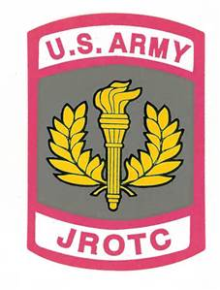

9-11 Commemorative/Hurricane Harvey Relief Program
On September 11, 2017, JROTC cadets sponsored their fourth annual 9-11 event and Hurricane Harvey service learning event JROTC cadets performed a memorial ceremony celebrating the lives of those lost during Hurricane Harvey, and the lives lost in the bombing of the Twin Towers on September 11, 2001. Hurricane Harvey caused widespread catastrophic flooding and damages in Texas and along the Gulf Coast. Vashon JROTC Cadets raise funds and provided relief for the Houston, Texas school districts. We send a very special “thank you” too all 9-11 ceremony participants and cadets who donated money for the Hurricane Harvey Relief Fund.
Lincoln Homecoming Parade
September 23, 2017, cadets volunteered and supported Lincoln University Homecoming parade, Jefferson City, MO. The sounds of marching bands marching, cheerleaders cheering and all the fun faces in the crowd was amazing! The experience was fun and exciting and all cadets enjoyed the community relations experience. While marching along the parade route, cadets encountered a familiar face, Ms. Brenda Irving, a Vashon HS and Lincoln University alumni. We (JROTC Cadets) send a special “Thank you” to the Vashon HS Drum line team who marched and played amazing music. JROTC cadets’ participants were Amber Stidmon, Ashjia Harris, Demarco Hodge, Monique Collins, Isaiah Whitlock, Shamaiya Moody, Naina Anderson, Dereona Nunley, Johnnita Womack, Devin Grant, Terrence Smith, Fatima Ndon, Jaylen White, Ryan Standley, Domonic Archie, A’yanna Madison, Ronajah Sanders, Aniya Dixson and Batrice Blockette
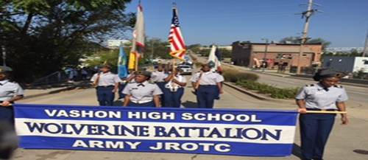
SLPS High School Recruiting @ Cleveland
On September 23, 2017, JROTC cadets assisted to recruit 8th graders to attend Vashon HS starting 17/18 school year. The event location was Cleveland HS. Cadets did a wonderful job communicating the benefits for attending Vashon. 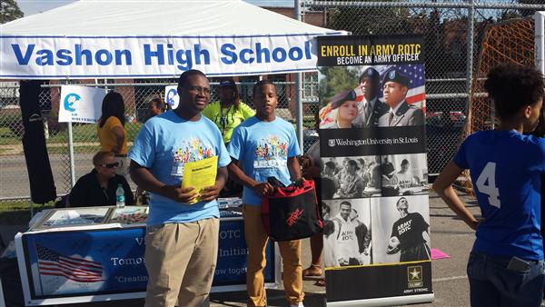 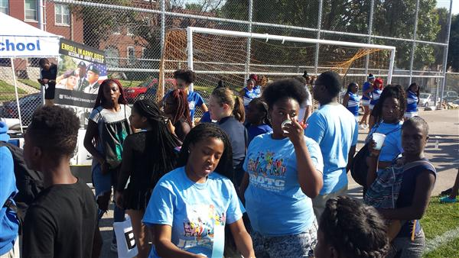
Shown in the photo above are cadets Isaiah Whitlock & Demarco Hodge.
Shown in the photo above are Cadets Ashjia Harris & Monique Collins

Sista Strut-St. Louis
Background: Studies show that African American women are more likely to get breast cancer at a younger age and have a death rate from breast cancer twice that of Caucasian women of the same age. A new report from the American Cancer Society finds that breast cancer rates among African-American women in the United States are increasing. Black women are more likely than other racial/ethnic groups to be diagnosed at later stages and have the lowest survival at each state of diagnosis.
For the past 7 years, the Sista Strut Breast Cancer Walk has heightened awareness about the issues of breast cancer in women of color, as well as provided information on resources and saved lives of women in our community. Vashon JROTC cadets volunteered and supported the large gathering at the downtown St. Louis Riverfront. Cadets provided route directions and motivational cheers to all participants that included our VHS staff members Ms. Jones Fowler, Ms. McQueen, & Ms. Cason, & Ms. Swift-Elliott. “Thank You” cadets (Amber Stidmon, Ashjia Harris, Demarco Hodge, Dereona Nunley, Monique Collins, Johnnita Womack, Terrence Smith, Devin Grant, Terrion Jones, Domonic Archie, Eldriyyah Jones, A’yanna Madison and Aubrey Logan). Photos posted on the next page.

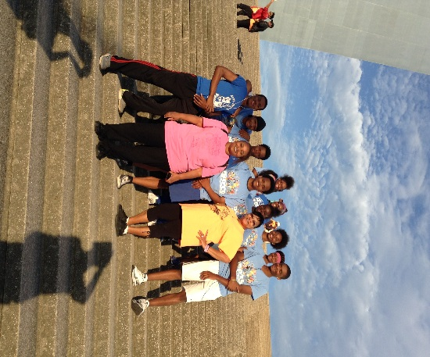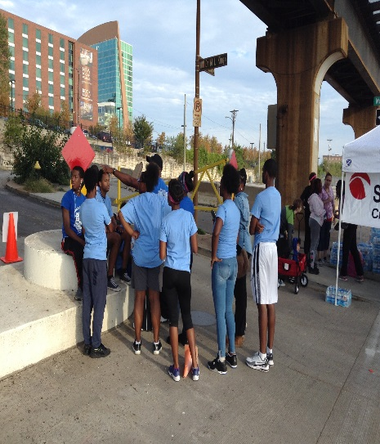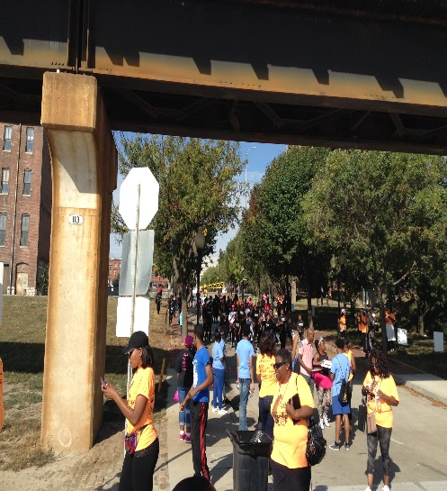

Meet VHS JROTC LET-4, 2018 Graduating Class
They started as 9th graders and pledged to stay and support the 4-year plan to transform Vashon HS JROTC into a first class character, leadership and citizenship program. During the 4-year period, ten cadets helped Vashon JROTC achieve successes. The seniors’ Grade Point Average is 3.0, they earned approximately 800 community service hours, participated in 15 Service Learning Projects and achieve a 94% attendance average. They planned and participated in two Red Cross Blood Drives that collected 35+ pints of blood that could save approximately 105 lives. The seniors currently serve and served in many different programs and organizations (student council, girls basketball, track & field, soccer, flag line, and cheering team). The LET-4 cadets mentored students at Dunbar Elementary School, celebrated Christmas Holiday seasons with residents at Garrison Nursing Center and they learned for the first time how to ski and rappel. The yearly etiquette and manners, public speaking, personal growth and physical fitness training proved invaluable for their successful high school career. Finally, they attended leadership camps and now are the key leaders for our JROTC program and Vashon High School.They started a legacy that current and future cadets can be proud to follow!

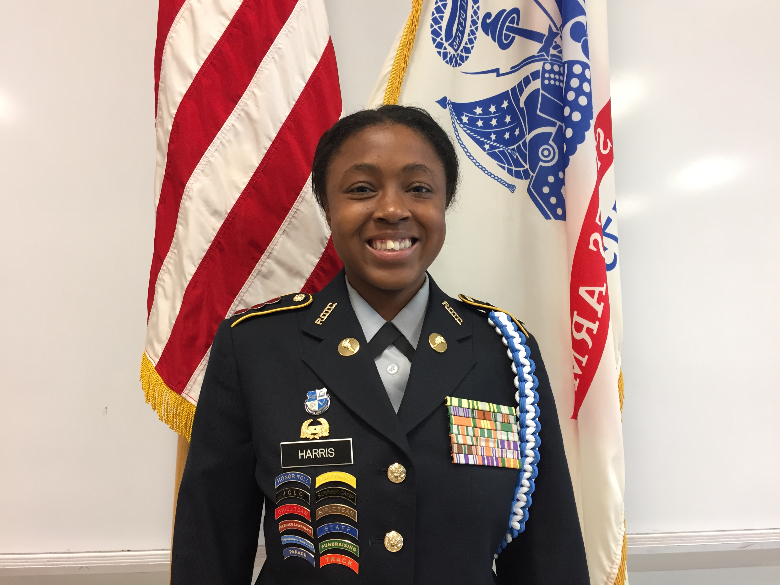
C/Captain Ashjia Harris
C/Battalion XO & S-2 (Security)
-4th Year Cadet
-3.5 Grade Point Average
-Earned 121Community Service Hours
-Career Plan-After HS, attend a college or university and become a therapist.
-My Senior Year- I am eagerly awaiting senior activities!
-JROTC Achievements-Leadership camps, leading JROTC events/activities, public speaking, and Awards (academic, citizenship, attendance, and community service).
-Advice for New JROTC Cadets
“You will enjoy yourself and it takes a lot of courage to step out of your comfort zone to become the student, cadet, daughter or son JROTC wants you to be!”

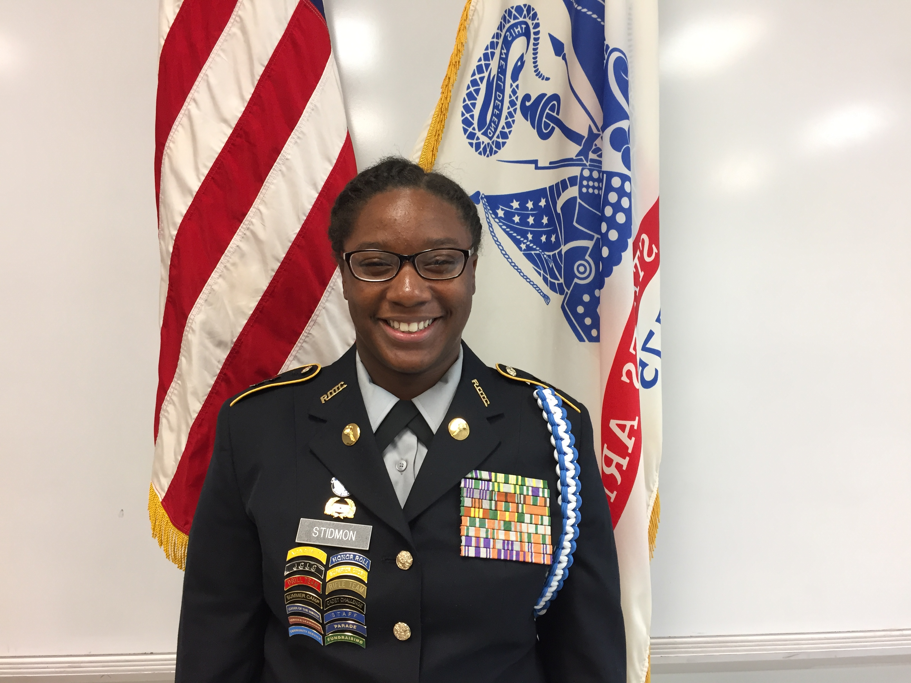
C/Amber Stidmon
C/Major Battalion Commander
Leader for VHS AJROTC Program
-4th Year Cadet
-3.4 Grade point Average
-Senior Class President
-Earned 370 Community Service Hours
-Career Plan-After HS, attend a 4-year college to become a Registered Nurse.
-My Senior Year-1st, enjoy! 2nd, walk across the stage!
-JROTC Achievements-Leadership Camps, Cadet of the Month, Cadet of the Year, Academic & Attendance Awards, and Citizenship Awards Color Guard Team & Drill & Rifle Teams membership/participation.
-Advice for New JROTC Cadets
I say, “always apply yourself and do not say you cannot; always participate!”

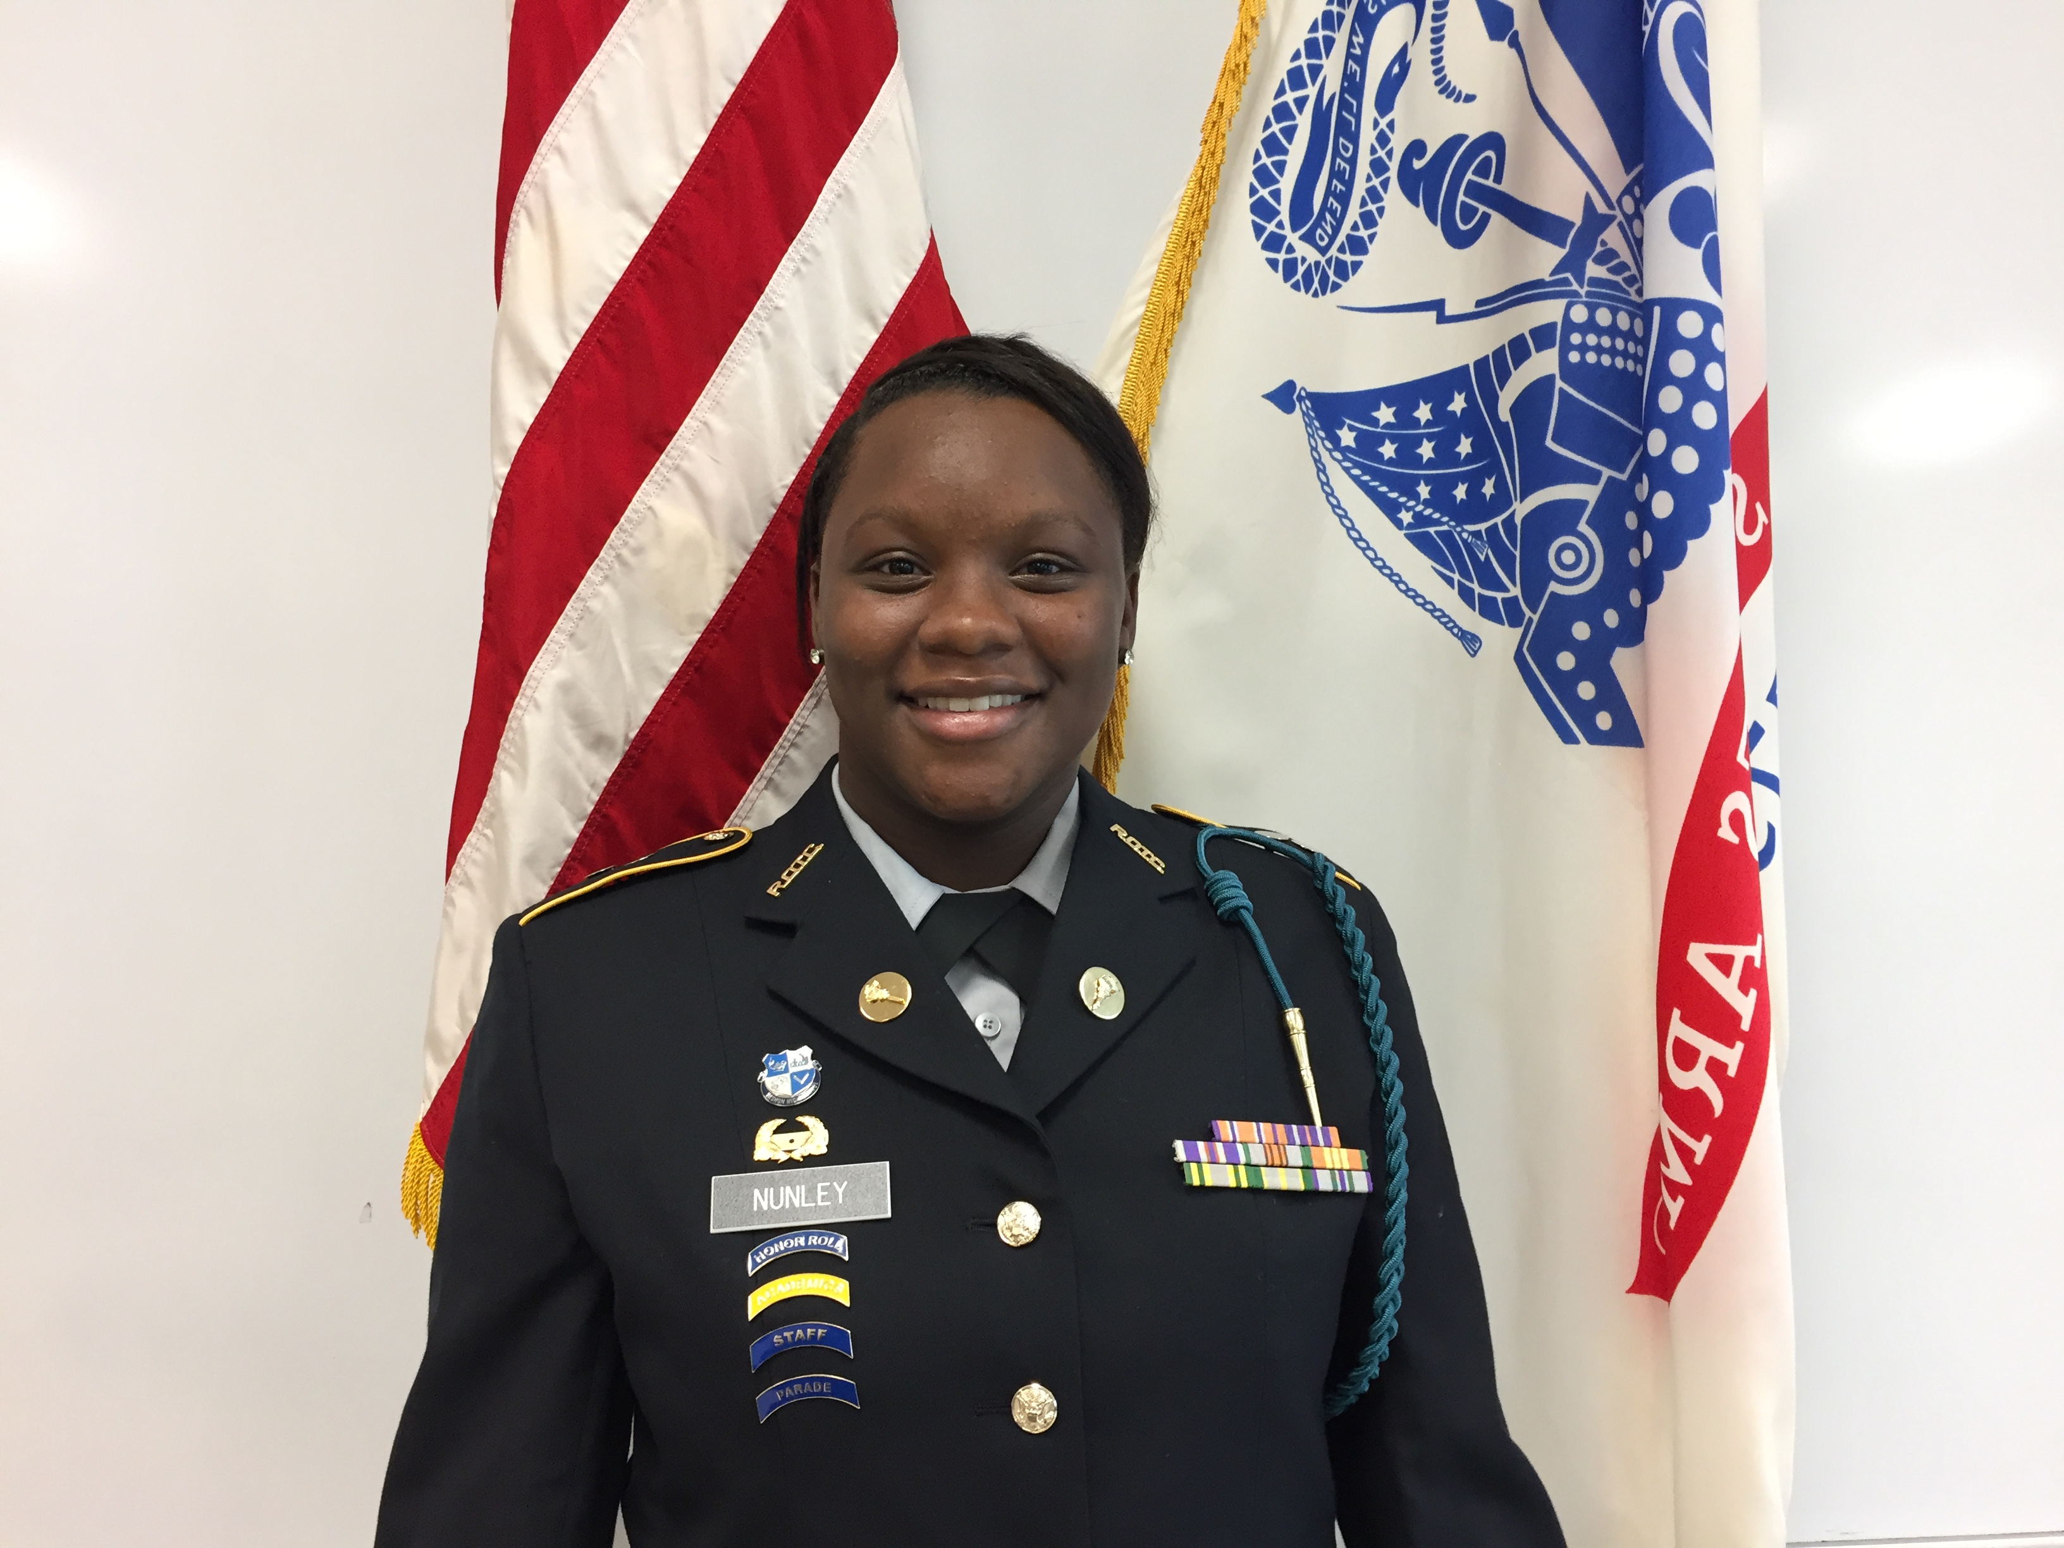
C/1st Lieutenant Dereona Nunley
C/Battalion S-1 (Personnel)
-4th Year Cadet
-2.9 Grade Point Average
-Senior Class Secretary
-Earned 31 Community Service Hours
-Career Plan-Attend a college or university and major in Mortuary Science.
-My Senior Year-“I am excited about PROM and graduation!”
-JROTC Achievements-Academic Awards and Color Guard Team. I’ve become a better citizen and a person.”
-Advice for New JROTC Cadets
“Be a leader and not a follower.”

C/ SFC Gemyiia Nichols
-3rd Year Cadet
-Earned 16 Community Service Hours
-Career Plan-Attend a college or university.
- Advice for New JROTC Cadets
“I recommend that you wear the JROTC uniform, attend class, and become involved in all JROTC activities & events.”

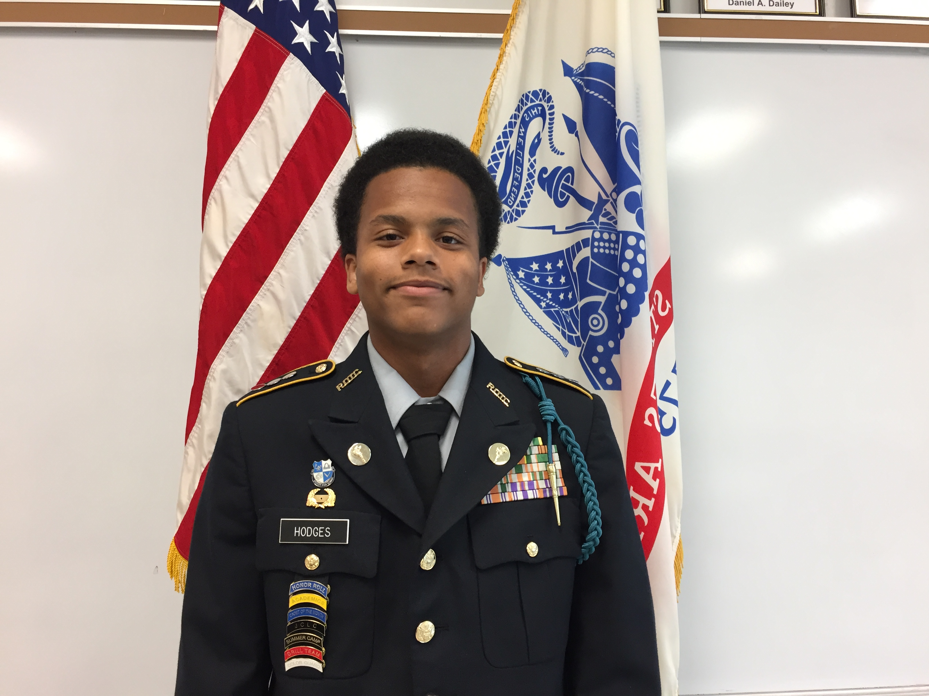
C/Captain Demarco Hodge
C/Battalion XO & S-6 (Technology)
-4th Year Cadet
-3.3 Grade Point Average
-Earned 72 Community Service Hours
-Career Plan-Join the military or attend a college or university.
-My Senior Year-“I am excited about earning my diploma and being able to say, I GRADUATED HS!”
-JROTC Achievements-Leadership Camps, leadership skills, Academic & Attendance Awards, Citizenship Awards, Color Guard Team & Drill (commander) & Rifle Teams membership/participation. I feel like a better citizen and a person as a whole.
-Advice for New JROTC Cadets
I recommend patient with everything, ask for help when you need it. I strongly suggest much participation for your benefits.

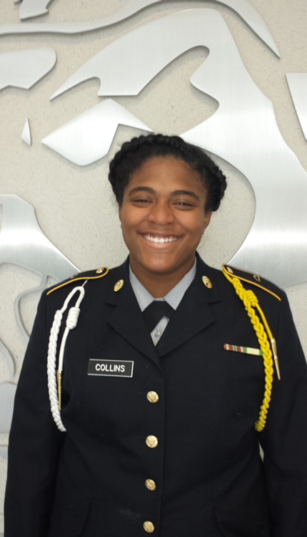
C/Captain Monique Collins
C/Battalion S-3 (Training/Operations
-4th Year Cadet
-3.0 Grade Point Average
-Earned 110 Community Service Hours
-Career Plan-Join the military while attending a 4-year university of my choice.
-My Senior Year-“I am excited about senior activities, PROM and graduation!”
-JROTC Achievements- Leadership camp, Academic & Attendance Awards, Color Guard Team Awards, Drill & Rifle Teams Awards. I’ve increased tremendously my self-confidence and public speaking skills.”
-Advice for New JROTC Cadets
“Stay focused!”
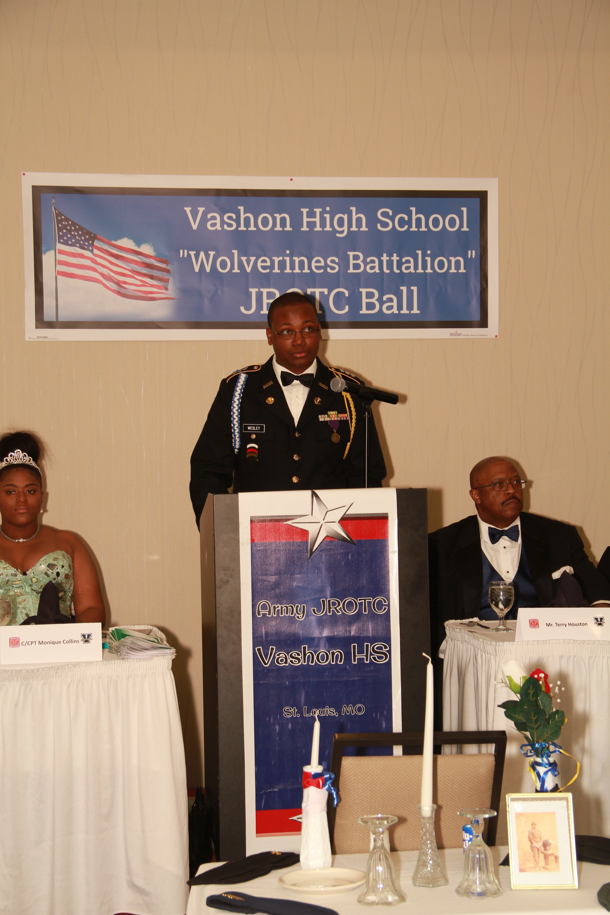
C/Captain Isaiah Whitlock
C/Company Commander
-4th Year Cadet
-2.1 Grade Point Average
-Senior Class Sergeant at Arms
-Earned 87 Community Service Hours
-Career Plan-Join the U.S. Navy and travel the world.
-My Senior Year-“I am excited about completing the ASVAB so that I can take the next step to enlist into the military!”
-JROTC Achievements-Leadership Camps, leadership skills, Attendance Awards, Citizenship Awards, Color Guard Team & Drill & Rifle Teams (commander) membership/participation.

C/Shamaiya Moody
C/Battalion S-4 (Logistics)
-4th Year Cadet
-2.0 Grade Point Average
-Earned 57 Community Service Hours
-Career Plan-Attend a college or university or join the U.S. Marines
-My Senior Year-“I am excited about Senior Activities and I can finally participate in after school activities!”
-JROTC Achievements-Community Service Awards. Drill and Rifle Teams Awards. I have learned that attending school is important; without school, you really cannot achieve must success in life! ”
-Advice for New JROTC Cadets
“Trust your fellow cadets and maintain good leadership!”

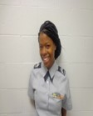
C/Naina Anderson
C/Company Commander
-4th Year Cadet
-2.9 Grade Point Average
-Earned 56 Community Service Hours
-Career Plan-Attend a college or university.
-My Senior Year-“I am excited about Senior Pictures, PROM, JROTC Ball and graduation!”
-JROTC Achievements-Academic and Community Service Awards. I have learn not to give up working hard because it pays off. Finally, believe in myself! ”
-Advice for New JROTC Cadets
“JROTC helps bring the good out of you!”

C/Ronisha Ross
-4th Year Cadet/Battalion S-5 (Public Affairs)
-Career Plan-Join and serve in the Army National Guard
-My Senior Year-“Participating in all activities and getting started in the real world!”
-JROTC Achievements- I have learned responsibility and self-control!
-Advice for New JROTC Cadets
Attend classes and show your best behavior and respect!

C/SSG Shamon/ Shaw
-4th Year Cadet
-2.6 Grade Point Average
-Career Plan-Attend a college or university.
-My Senior Year- I get to
experience attending PROM.
- Advice for New JROTC Cadets
Obey your JROTC Instructors!

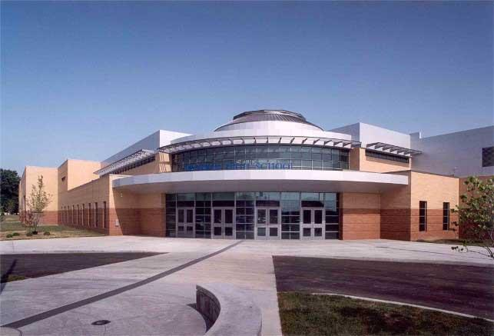
http://www.slps.org/vashon/JROTC
Army JROTC Creed (Belief or Promise for oneself)
The idea of a creed for JROTC originated in various high schools across the nation. During the many visits he made throughout the command in his first year as ROTC chief, Major General Lyle frequently encountered junior units that had on their own initiative come up with a creed. It seemed to the Commanding General that this reflected a deep-seated need among cadets for such a statement purpose. Accordingly, he charged his High School Directorate with the task of drafting one. Mr. Cal Foster took the lead in this project. Incorporating suggestions from the field, he produced a creed that read:
I am an Army Junior ROTC Cadet.
I will always conduct myself to bring credit to my family, country,
school and the Corps of Cadets. I am loyal and patriotic.
I am the future of the United States of America.
I do not lie, cheat or steal and will always be accountable for my actions and deeds.
I will always practice good citizenship and patriotism.
I will work hard to improve my mind and strengthen my body.
I will seek the mantle of leadership and stand prepared to uphold the Constitution and the American way of life.
May God grant me the strength to always live by this creed?
Vashon High School
3035 Cass Avenue
St. Louis, MO 63106

JROTC Instructors:
Sergeant Major Walter Wright, Senior Army Instructor
Sergeant First Class Lorenzo Harris, Army Instructor
JROTC Upcoming Events
October 2017
1-27-JLAB Practice Round
5- VHS Alumni visit VHS
7- Cadets support Sista Strut, STL River front
7- Color Guard @ Alumni Dinner, Present Colors
11-ASVAB Testing @ VHS
9-12-VHS Spirit Week
13-No School for Cadets: SLPS PD
13- 3rd Quarter Ends
14-VHS Homecoming Football Game
16-17- Uniform Day
18-19 Parent Teacher Conference
20-No School for Cadets
31-Newsletter published/JPA Staff Meeting/Inventories
November 2017
1-3- JLAB Team Competition
7-JPA Accreditation Review for all JROTC Cadets
9-Service Learning Veterans Day Program
11- STL Veterans Day Parade
22-24-Thanksgiving Holiday Period
29-Drill Meet; Cadet Staff Meeting
30-Cadet of the Month Selected
31- JROTC Newsletter Published, website updated, training calendar published, JUMS Updated & weapons inventory

